|  |  |
| --- | --- |
|  | CO­2 Monitor Instructions |

|  |  |  |  |  |  |
| --- | --- | --- | --- | --- | --- |
| Date: | 29/05/21 | Version: | 1.0 | By: | Matt Little |

|  |  |
| --- | --- |
|  | *This is an ESP8266 based Carbon Dioxide (CO2) level monitor, with small OLED display, a rotary encoder for user input and five Red-Green-Blue WS2812 LEDs.*  The main processor is based upon the [ESP8266 system-on-chip from Espressif Systems](https://en.wikipedia.org/wiki/ESP8266).  This can be programmed via the Arduino IDE, if you would like to make changes.  *This is a reasonably simple kit which requires some soldering.*  *This kit requires a micro-USB lead for programming and powering the unit.*  *Not suitable for under 12 years old.* |

# Parts included:

|  |  |  |  |  |  |  |  |  |
| --- | --- | --- | --- | --- | --- | --- | --- | --- |
|  |  |  | 5 x 100nf Capacitors | | 4 way header |  |  | OLED  Display |
| PCB  with LEDs, level shifter and micro USB pre-soldered |  | | | | | | |
|  |
|  |
| M2 Nylon Nut |
|  |
| 2 x 1N5819  Diodes | M2 Nylon Spacer |
| M2 Nylon Screw |
| Switch |  |
|  |  |
| MH-Z14A  Carbon  Dioxide  Sensor |
| 500mA Fuse |
|  |  | Rotary Encoder | |  | 2 x 15 pin headers | ESP8266  NodeMCU  Amica |  |  |

# Parts list:

|  |  |  |
| --- | --- | --- |
| **Item** | **Ref** | **Quantity** |
| Capacitors. 100nf | C1-5 | 5 |
| Diode. 1N5819 | D1, D2 | 2 |
| LED. WS2812 (pre soldered) | D3-7 | 5 |
| LED. Red. NOT included | B8 | Not Included |
| Display. OLED. 0.96"  With 4-way header | DISP1 | 1 |
| Encoder | ENC1 | 1 |
| Fuse. 500MA | F1 | 1 |
| USB micro Socket (pre-soldered) | P1 | 1 |
| 2 way screw terminal. 5V. Not Included | P2 | Not Included |
| HC-11 Serial. Optional | P3 | Not Included |
| Software Serial. Optional | P4 | Not Included |
| Node MCU header. 15 way. | P5, P6 | 2 |
| PCB – with SMD parts soldered |  | 1 |
| 330ohm Resistor. Not Included | R1 | Not Included |
| Switch | SW1 | 1 |
| NodeMCU  with 2 x 15 way headers | U1 | 2 |
| 74LVC1G17 Level shifter (pre-soldered) | U2 | 1 |
| M2 Machine screws. Plastic. 6mm long |  | 2 |
| M2 Nuts. Plastic |  | 2 |
| M2 Spacers. Plastic. 12mm long |  | 2 |
| MH-Z14A Winsen CO2 Sensor Unit |  | 1 |

# Enclosure Parts:

|  |  |  |
| --- | --- | --- |
|  |  | Back |
|  |  | M3 12mm screws |
| Front |  |
|  | M3 15mm spacer |
| Spacer |
|  | M2 Screws |
| Sensor cable (not required!) |  |
| M2 nuts |
| 4 x Cable Pieces | M3 10mm spacer |
|  |
| Knob | M3 6mm screws |
|  |  |  |

# Hardware

|  |  |  |
| --- | --- | --- |
| **Item** | **Ref** | **Quantity** |
| M2 Machine screws. 12mm long |  | 3 |
| M2 Nuts |  | 3 |
| M3 Machine screws. 6mm long |  | 4 |
| M3 Machine screws 12mm long |  | 4 |
| M3 Threaded Hex spacers. 10mm long |  | 4 |
| M3 Threaded Hex spacers. 15mm long |  | 4 |
| Front. Laser cut 3mm Frosted Acrylic |  | 1 |
| Spacer. Laser cut 3mm Black. Acrylic |  | 1 |
| Back. Laser cut 3mm Frosted Acrylic |  | 1 |
| Cable. Single Strand. For wiring sensor |  | 4 |
| Knob |  | 1 |

# Tools required:

|  |  |  |
| --- | --- | --- |
|  |  |  |
|  | Long-nosed  Pliers |
| Soldering Iron | Posi-drive  Screwdriver |
| Solder |  |
| Side cutters |  |
|  |  |
|  |  |
|  |  |

# Additional Items Required

* 1 x Micro-USB lead (for powering and for programming)
* 1 x 5V USB power supply (might be required for powering stand-alone unit)
* To update/change code: Computer with Arduino IDE and additional libraries installed. (see software section for more details)

# Instructions:

|  |  |  |
| --- | --- | --- |
| **Step: 1** | Solder diodes | |
| There are two diodes to solder in to the two components marked D1 and D2.  Ensure correct polarity! The white band on the diode should align with the black band on the PCB silkscreen. | |  |

|  |  |  |
| --- | --- | --- |
| **Step: 2** | Solder capacitors | |
|  | | There are five 100nf capacitors to solder into the holes marked C1 to C5.  These capacitors do not have any polarity. |

|  |  |  |
| --- | --- | --- |
| **Step: 3** | Solder switch | |
| The right-angled switch should be soldered into SW1. | |  |

|  |  |  |
| --- | --- | --- |
| **Step: 4** | Solder fuse | |
|  | | The 500mA resettable fuse should be soldered into the hole marked F1.  The fuse does not have any polarity. |

|  |  |  |
| --- | --- | --- |
| **Step: 5** | Solder header pins | |
| Solder the 4 way header block into the holes marked DISP1.  The 15 way headers are soldered into the NodeMCU area marked U1.  Do not solder anything into the holes marked P5 and P6 – these are connections for any external circuits you might want to add. | |  |

|  |  |  |
| --- | --- | --- |
| **Step: 6** | Solder encoder | |
|  | | The encoder is soldered into the area marked ENC1.  Solder the two larger pads first to hold the encoder in place. Ensure the encoder is straight when soldered, as this goes through the front of the case, with the plastic knob added at the end. |

|  |  |  |
| --- | --- | --- |
| **Step: 7** | Fit OLED module | |
|  | | The OLED unit pushes into the 4 way header pins soldered in step 6.  There are two 2.5mm spacers. The long plastic spacer is placed with the threaded male section through the holes and the nuts added to hold them in place.  Then put in the OLED module and fit the two 2.5mm machine screws from the top of the OLED module, as shown in the picture. |

|  |  |  |
| --- | --- | --- |
| **Step: 8** | Solder wires to CO­­2 sensor | |
| You now need to wire the CO2 sensor to the yellow main PCB.  Use the 4 pieces of wire.  Strip 5mm of the end of the wire from each end of all 4 pieces of wire. Solder from the back of both PCBs (the opposite side to the CO2 sensor image shown here).  Use the following connections and solder the cable to the following points on the CO2 sensor:   * Black -> Pin 2 * Red -> Pin 1 * Green -> Pin 10 * Brown -> Pin 11   Use the following connections and solder the cable to the following points on the yellow PCB:   * Black -> GND * Red -> Vin * Green -> Tx * Brown -> Rx | |  |
|  | |  |

|  |  |  |
| --- | --- | --- |
| **Step: 9** | Fit Node MCU | |
| The NodeMCU unit pushes into the two 15 way header strips.  Ensure that the USB socket is above the ‘PROG USB’ area.  Double check this before powering on!  The NodeMCU has been pre-programmed with a test code. This should run when powered. | |  |

|  |  |  |
| --- | --- | --- |
| **Step: 10** | PCB is finished! | |
| A cup of coffee and a bagel on a saucer  Description automatically generated with medium confidenceHave a nice cup of tea. | | Test with micro-USB cable. The USB power cable can either be plugged into the NodeMCU (used for programming the unit) or it can be plugged in to the USB_Micro socket (only used to power the unit – there is no communication through this socket).  Switch on and check:   * LEDs light * OLED screen shows data * Rotary Encoder changes data on OLED   This should prove that the functions of the PCB and the NodeMCU are working OK. |

# Enclosure

|  |  |  |
| --- | --- | --- |
| **Step: 11** | Remove protective plastic film | |
|  | |  |

|  |  |  |
| --- | --- | --- |
| **Step: 12** | Add spacer | |
| There are four spacers to add, each one is comprised on a short spacer with male and female ends and a female-female longer spacer.  The shorted spacer should go through from the bottom of the PCB, with the longer spacer screwed on top, as shown in the picture. | |  |

|  |  |  |
| --- | --- | --- |
| **Step: 13** | Add CO2 sensor to back | |
| Diagram, engineering drawing  Description automatically generated  Parts required.    Place CO2 sensor as shown here. The white section contains the sensor. | | Use the 3 x M2 metal screws and nuts to hold in place.   |

|  |  |  |
| --- | --- | --- |
| **Step: 14** | Add enclosure and knob | |
|  | | The shorter M3 screws are used to hold the back enclosure plate in place. The back enclosure plate has a hook hole and the cut-out for the CO2 sensor (not shown here).  The front should have the black cover placed on first, then the front enclosure plate added. The 15mm M3 screws then hold this in place on the front of the unit into the spacers added in step 12.  The knob for the rotary encoder can also be pushed on. This is sometimes a little difficult and may require some force – it is a push fit. |

|  |  |  |
| --- | --- | --- |
| **Step: 14** | Finished build! | |
| Now the unit can be plugged in using a micro-USB lead. It should power on and start to show information on the OLED screen.  If not, then please check:   * Is the ESP8266 unit correctly installed and LED lights ON? * Check soldering and connections.   The unit can also be programmed to show data from the internet, or to upload data from the internet. It can also be used as a stand-alone unit.  The limit to this unit is only your imagination and coding skills! | |  |

# Software

|  |  |
| --- | --- |
| **Step: 15** | Software Overview |
|  | |

|  |  |
| --- | --- |
| **Step: 16** | Upload software |
| This is not needed for standard use of the unit.  This is where the fun begins!  This project has software stored on GITHUB software repository here:  **https://github.com/curiouselectric/CO2Monitor**  Please follow the readme in this file for the most up to date instructions for uploading code using the Arduino IDE (or any other IDE of your choice).  This GITHUB contains all the design files as well as the software code. Move to the “FIRMWARE” folder for the software example. | |

# Contact details:

This kit has been designed and produced by:

The Curious Electric Company

[**hello@curiouselectric.co.uk**](mailto:hello@curiouselectric.co.uk)

[**www.curiouselectric.co.uk**](http://www.curiouselectric.co.uk/)

Unit 23, Block D, Hartley Business Centre, Haydn Road, Nottingham, NG5 1DG

We would like you to be happy with this kit. If you are not happy for any reason, then please contact us and we will help to sort it out.

Please email [**hello@curiouselectric.co.uk**](mailto:hello@curiouselectric.co.uk) with any questions or comments.

Please tweet us at **@curiouselectric**

If any parts are missing from your kit then please email [**hello@curiouselectric.co.uk**](mailto:hello@curiouselectric.co.uk) with details, including when and where the kit was purchased.

More technical information can be found via [**www.curiouselectric.co.uk**](http://www.curiouselectric.co.uk/)

# Circuit Schematic:

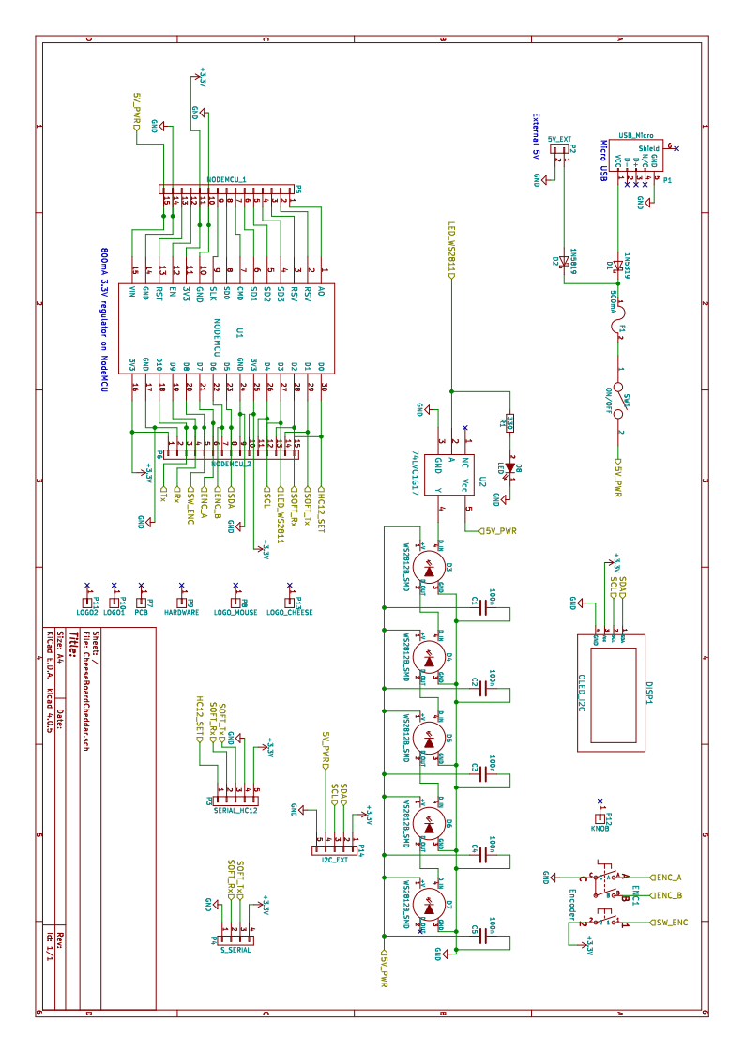

# PCB Design:

# 